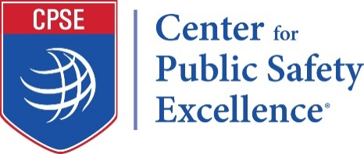 News

FOR IMMEDIATE RELEASE Media Contact:
[DATE] Mike Higgins, CPC Program Manager
www.cpse.org 703.691.4620
mhiggins@cpse.org

[Insert Officer’s Name] Completes International Professional
Designation Process

(Insert officer’s name) has successfully completed the process that awards the professional designation of “Chief Training Officer” (CTO). The Commission on Professional Credentialing® (CPC®) met on (Insert Date) to confer the designation. [Insert officer’s name] becomes one of only [Insert Number] CTOs worldwide.

The Designation program is a voluntary program designed to recognize individuals who demonstrate their excellence in seven measured components including experience, education, professional development, professional contributions, association membership, community involvement, and technical competence. In addition, all applicants are required to identify a future professional development plan.

The CTO designation program uses a comprehensive peer review model to evaluate candidates seeking the credential. The Commission on Professional Credentialing awards the designation only after an individual successfully meets all the organization’s stringent criteria.

Achieving this designation signifies [insert officer’s name] career commitment to the fire and emergency services.

This professional designation is valid for three years. Maintaining the designation requires recipients to show continued growth in the areas of professional development, professional contributions, active association membership, and community involvement as well as adhere to a strict code of professional conduct

The Commission on Professional Credentialing, an entity of the Center for Public Safety Excellence®, Inc., (CPSE®) administers the Designation Program. The CPC consists of individuals from academia, federal and local government, and the fire and emergency medical services profession. To learn more about CPC, visit www.cpse.org/credentialing.
######

