Credentialing Images and Text

Congratulations on becoming a designated Fire Officer. CPSE has provided images and text to help you announce your designation as a Fire Officer on Twitter, LinkedIn, and Facebook by providing appropriately sized images to denote your new credential and suggested text to accompany it. The graphic below is provided in three sizes and labeled for corresponding social media site.

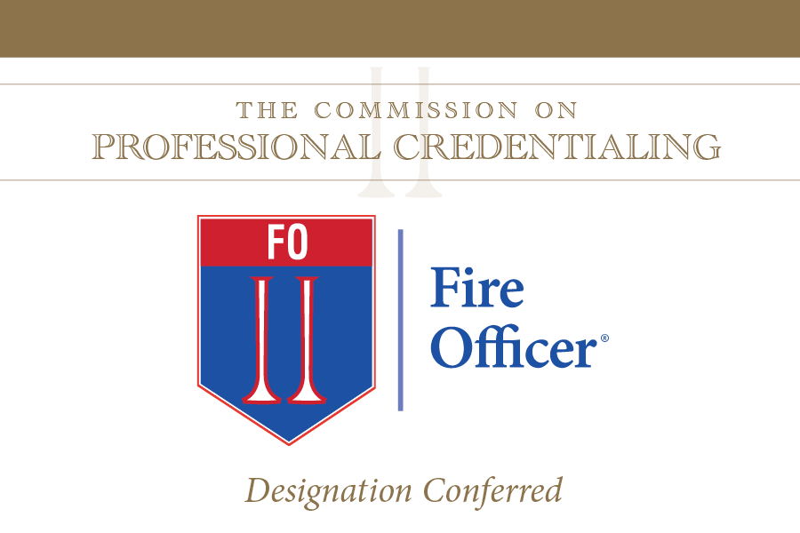

The Commission on Professional Credentialing® has just awarded (me or person’s name) the professional designation of Chief Fire Officer on (date credential conferred). Following an extensive peer review process, this designation recognizes demonstrated excellence in seven measured components: experience, education, professional development, professional contributions, association membership, community involvement, and technical competence. In receiving this designation, (I or person’s name) become(s) one of only XXX FO’s worldwide.

Meeting these stringent requirements will allow (me or person’s name) to bring a higher level of professionalism and service to (insert city/community name).

#CPSECPC

