Credentialing Images and Text

Congratulations on becoming a designated Fire Marshal (FM). CPSE has provided images and text to help you announce your designation on Twitter, LinkedIn, and Facebook by providing appropriately sized images to denote your new credential and suggested text to accompany it. The graphic below is provided in three sizes and labeled for corresponding social media site.

Sample text is provided below. Feel free to modify this text as appropriate for your agency and community.

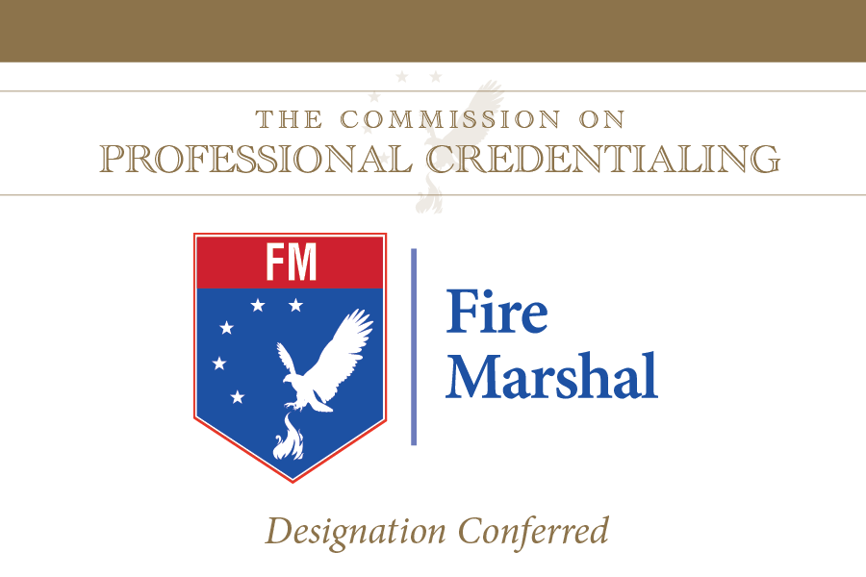

The Commission on Professional Credentialing® has just awarded (me or person’s name) the professional designation of Fire Mashal on (date credential conferred). Following an extensive peer review process, this designation recognizes demonstrated excellence in seven measured components: experience, education, professional development, professional contributions, association membership, community involvement, and technical competence. In receiving this designation, (I or person’s name) become(s) one of only XXX FM’s worldwide.

Meeting these stringent requirements will allow (me or person’s name) to bring a higher level of professionalism and service to (insert city/community name).

#CPSECPC

